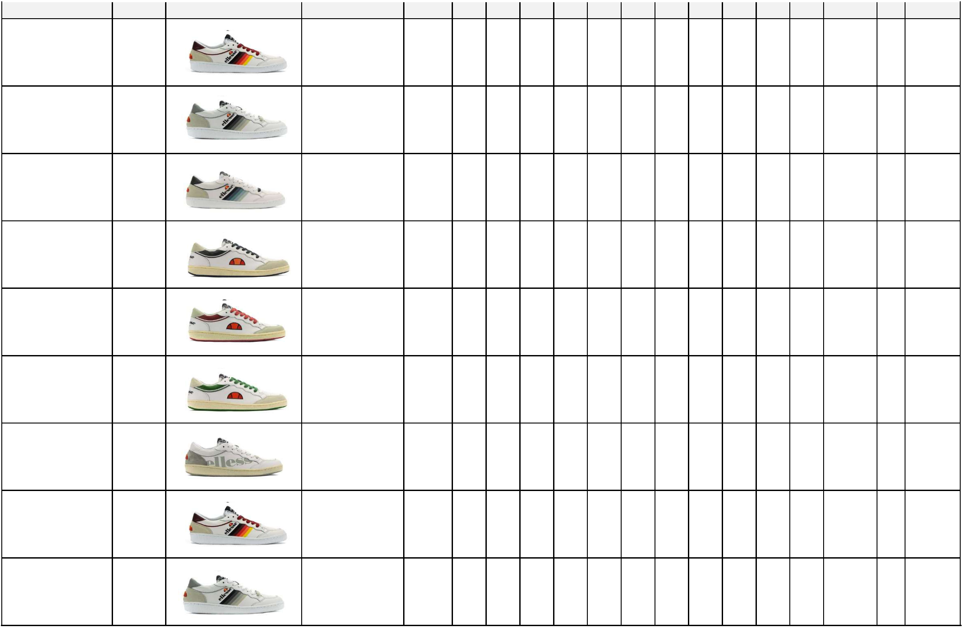  BRAND | SEASON | PICTURE | ITEM NO. | ASST | 36 | 37 | 38 | 39 | 40 | 41 | 42 | 43 | 44 | 45 | 46 TOT PRS | CRT
ELLESSE HERITAGE | SS19 |  | OS EL91502/01 | U8 |  |  |  |  | 1 | 1 | 2 | 2 | 1 | 1 | 8 | 1
ELLESSE HERITAGE | SS19 |  | OS EL91502/02 | U8 |  |  |  |  | 1 | 1 | 2 | 2 | 1 | 1 | 8 | 1
ELLESSE HERITAGE | SS19 |  | OS EL91502/04 | U8 |  |  |  |  | 7 | 7 | 14 | 14 | 7 | 7 | 56 | 7
ELLESSE HERITAGE | SS19 |  | OS EL91503/01 | U8 |  |  |  |  | 7 | 7 | 14 | 14 | 7 | 7 | 56 | 7
ELLESSE HERITAGE | SS19 |  | OS EL91503/02 | U8 |  |  |  |  | 10 | 10 | 20 | 20 | 10 | 10 | 80 | 10
ELLESSE HERITAGE | SS19 |  | OS EL91503/03 | U8 |  |  |  |  | 4 | 4 | 8 | 8 | 4 | 4 | 32 | 4
ELLESSE HERITAGE | SS19 |  | OS EL91504/03 | U8 |  |  |  |  | 4 | 4 | 8 | 8 | 4 | 4 | 32 | 4
ELLESSE HERITAGE | SS19 |  | OS EL91502/01 | U6 |  |  |  |  |  | 2 | 4 | 4 | 2 |  | 12 | 2
ELLESSE HERITAGE | SS19 |  | OS EL91502/02 | U6 |  |  |  |  |  | 6 | 12 | 12 | 6 |  | 36 | 6

Pagina 1 di 7

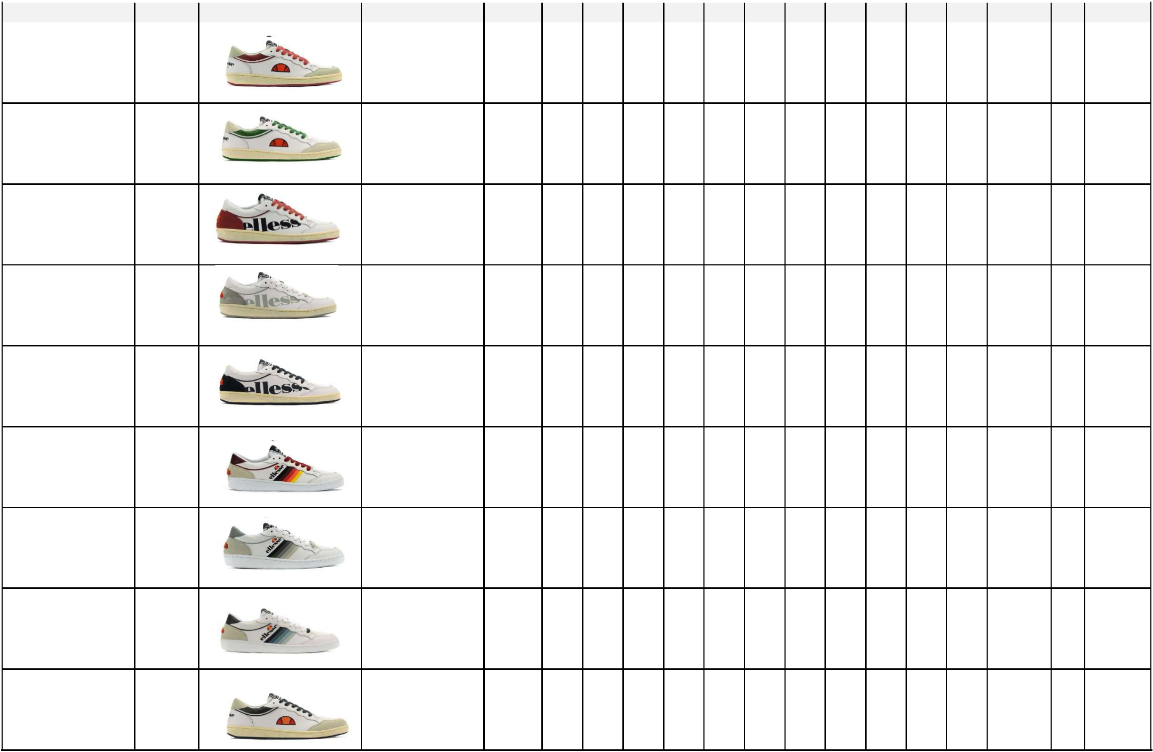 | BRAND | SEASON | PICTURE | ITEM NO. | ASST | 36 | 37 | 38 | 39 | 40 | 41 | 42 | 43 | 44 | 45 | 46 TOT PRS | CRT
 | ELLESSE HERITAGE | SS19 |  | OS EL91503/02 | U6 |  |  |  |  |  | 2 | 4 | 4 | 2 |  | 12 | 2
 | ELLESSE HERITAGE | SS19 |  | OS EL91503/03 | U6 |  |  |  |  |  | 2 | 4 | 4 | 2 |  | 12 | 2
 | ELLESSE HERITAGE | SS19 |  | OS EL91504/02 | U6 |  |  |  |  |  | 7 | 14 | 14 | 7 |  | 42 | 7
 | ELLESSE HERITAGE | SS19 |  | OS EL91504/03 | U6 |  |  |  |  |  | 8 | 16 | 16 | 8 |  | 48 | 8
 | ELLESSE HERITAGE | SS19 |  | OS EL91504W/01 | U6 |  |  |  |  |  | 11 | 22 | 22 | 11 |  | 66 | 11
 | ELLESSE HERITAGE | SS19 |  | OS EL91502/01 | U10 |  |  |  |  | 4 | 8 | 8 | 8 | 8 | 4 | 40 | 4
 | ELLESSE HERITAGE | SS19 |  | OS EL91502/02 | U10 |  |  |  |  | 2 | 4 | 4 | 4 | 4 | 2 | 20 | 2
 | ELLESSE HERITAGE | SS19 |  | OS EL91502/04 | U10 |  |  |  |  | 3 | 6 | 6 | 6 | 6 | 3 | 30 | 3
 | ELLESSE HERITAGE | SS19 |  | OS EL91503/01 | U10 |  |  |  |  | 2 | 4 | 4 | 4 | 4 | 2 | 20 | 2

Pagina 2 di 7

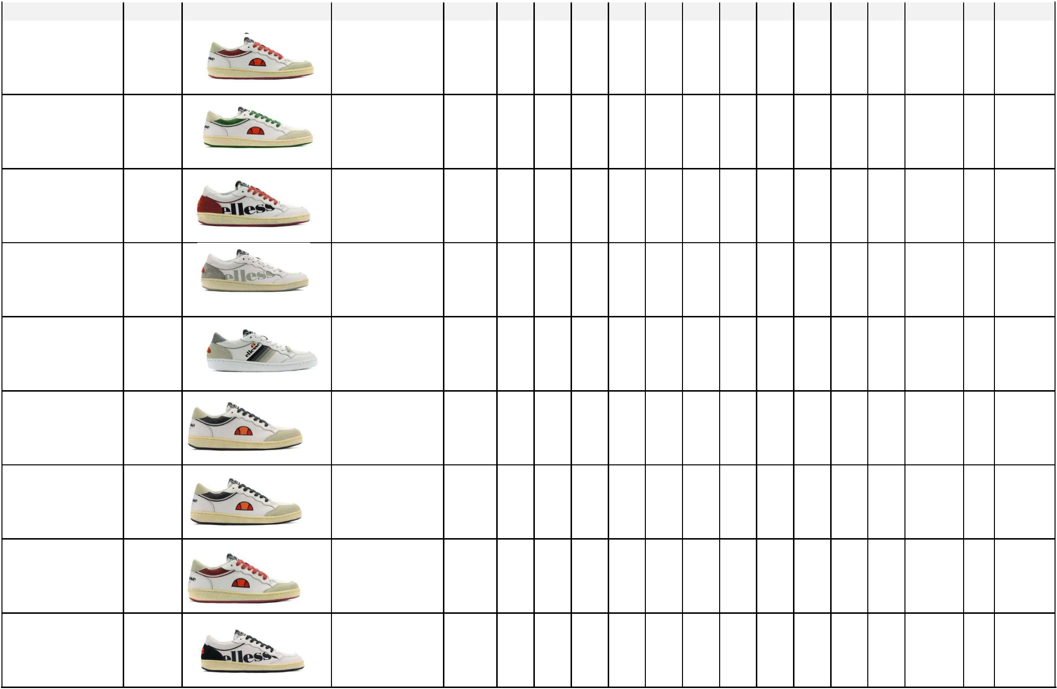 | BRAND | SEASON | PICTURE | ITEM NO. | ASST | 36 | 37 | 38 | 39 | 40 | 41 | 42 | 43 | 44 | 45 | 46 TOT PRS | CRT
 | ELLESSE HERITAGE | SS19 |  | OS EL91503/02 | U10 |  |  |  |  | 3 | 6 | 6 | 6 | 6 | 3 | 30 | 3
 | ELLESSE HERITAGE | SS19 |  | OS EL91503/03 | U10 |  |  |  |  | 1 | 2 | 2 | 2 | 2 | 1 | 10 | 1
 | ELLESSE HERITAGE | SS19 |  | OS EL91504/02 | U10 |  |  |  |  | 2 | 4 | 4 | 4 | 4 | 2 | 20 | 2
 | ELLESSE HERITAGE | SS19 |  | OS EL91504/03 | U10 |  |  |  |  | 1 | 2 | 2 | 2 | 2 | 1 | 10 | 1
 | ELLESSE HERITAGE | SS19 |  | OS EL91502/02 | SOLID |  |  |  |  |  | 1 | 2 | 2 | 1 | 1 | 7
 | ELLESSE HERITAGE | SS19 |  | OS EL91503-01 | SOLID |  |  |  |  | 3 | 6 | 6 | 5 | 4 | 2 | 26
 | ELLESSE HERITAGE | SS19 |  | OS EL91503-03 | SOLID |  |  |  |  | 2 | 4 | 4 | 4 | 4 | 2 | 20
 | ELLESSE HERITAGE | SS19 |  | OS EL91503W-03 | SOLID |  | 1 | 2 | 2 | 1 |  |  |  |  |  | 6
 | ELLESSE HERITAGE | SS19 |  | OS EL91504/01 | SOLID |  |  |  |  |  | 1 | 2 | 2 | 1 | 1 | 7

Pagina 3 di 7

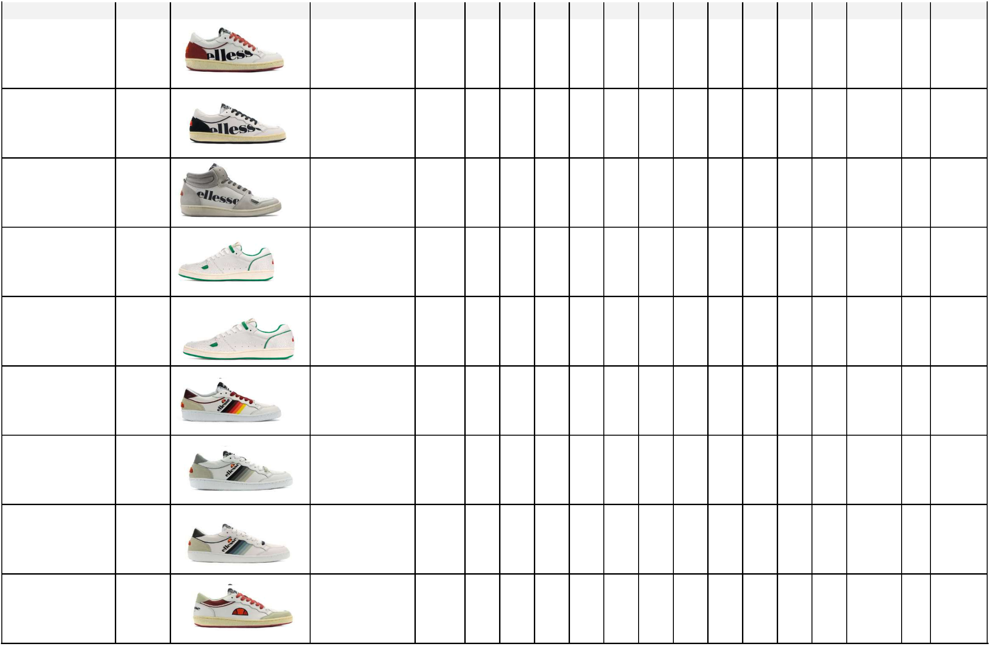 | BRAND | SEASON | PICTURE | ITEM NO. | ASST | 36 | 37 | 38 | 39 | 40 | 41 | 42 | 43 | 44 | 45 | 46 TOT PRS | CRT
 | ELLESSE HERITAGE | SS19 |  | OS EL91504/02 | SOLID |  |  |  |  |  | 1 | 2 | 2 | 1 | 1 | 7
 | ELLESSE HERITAGE | SS19 |  | OS EL91504W/01 | SOLID |  | 1 | 2 | 1 | 1 |  |  |  |  |  | 5
 | ELLESSE HERITAGE | FW18 |  | OS EL82449-01 | SOLID |  |  |  |  | 1 | 1 | 2 | 2 | 1 | 1 | 8
 | ELLESSE HERITAGE | FW17 |  | EL724463-05 | SOLID |  |  |  |  | 2 | 1 | 5 | 4 | 2 | 2 | 16
 | ELLESSE HERITAGE | FW17 |  | EL724463/05 | ELM02 |  |  |  |  | 1 | 1 | 2 | 2 | 1 | 1 | 8 | 1
 | ELLESSE HERITAGE | SS19 |  | OS EL91502W/01 | D8 | 3 | 6 | 6 | 6 | 3 |  |  |  |  |  | 24 | 3
 | ELLESSE HERITAGE | SS19 |  | OS EL91502W/02 | D8 | 2 | 4 | 4 | 4 | 2 |  |  |  |  |  | 16 | 2
 | ELLESSE HERITAGE | SS19 |  | OS EL91502W/04 | D8 | 2 | 4 | 4 | 4 | 2 |  |  |  |  |  | 16 | 2
 | ELLESSE HERITAGE | SS19 |  | OS EL91503W/02 | D8 | 5 | 10 | 10 | 10 | 5 |  |  |  |  |  | 40 | 5

Pagina 4 di 7

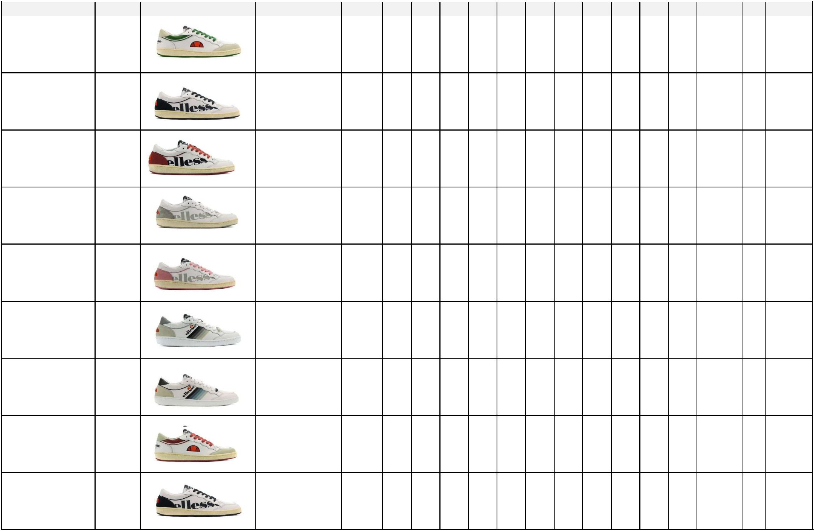 | BRAND | SEASON | PICTURE | ITEM NO. | ASST | 36 | 37 | 38 | 39 | 40 | 41 | 42 | 43 | 44 | 45 | 46 TOT PRS | CRT
 | ELLESSE HERITAGE | SS19 |  | OS EL91503W/03 | D8 | 1 | 2 | 2 | 2 | 1 |  |  |  |  |  | 8 | 1
 | ELLESSE HERITAGE | SS19 |  | OS EL91504W/01 | D8 | 3 | 6 | 6 | 6 | 3 |  |  |  |  |  | 24 | 3
 | ELLESSE HERITAGE | SS19 |  | OS EL91504W/02 | D8 | 4 | 8 | 8 | 8 | 4 |  |  |  |  |  | 32 | 4
 | ELLESSE HERITAGE | SS19 |  | OS EL91504W/03 | D8 | 5 | 10 | 10 | 10 | 5 |  |  |  |  |  | 40 | 5
 | ELLESSE HERITAGE | SS19 |  | OS EL91504W/04 | D8 | 9 | 18 | 18 | 18 | 9 |  |  |  |  |  | 72 | 9
 | ELLESSE HERITAGE | SS19 |  | OS EL91502W/02 | D6 |  | 2 | 4 | 4 | 2 |  |  |  |  |  | 12 | 2
 | ELLESSE HERITAGE | SS19 |  | OS EL91502W/04 | D6 |  | 2 | 4 | 4 | 2 |  |  |  |  |  | 12 | 2
 | ELLESSE HERITAGE | SS19 |  | OS EL91503W/02 | D6 |  | 1 | 2 | 2 | 1 |  |  |  |  |  | 6 | 1
 | ELLESSE HERITAGE | SS19 |  | OS EL91504W/01 | D6 |  | 2 | 4 | 4 | 2 |  |  |  |  |  | 12 | 2

Pagina 5 di 7

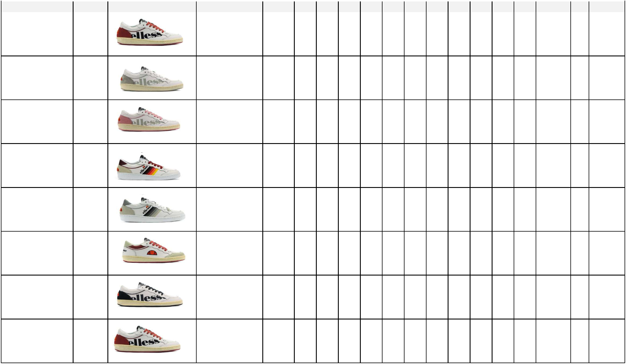 | BRAND | SEASON | PICTURE | ITEM NO. | ASST | 36 | 37 | 38 | 39 | 40 | 41 | 42 | 43 | 44 | 45 | 46 TOT PRS | CRT
 | ELLESSE HERITAGE | SS19 |  | OS EL91504W/02 | D6 |  | 6 | 12 | 12 | 6 |  |  |  |  |  | 36 | 6
 | ELLESSE HERITAGE | SS19 |  | OS EL91504W/03 | D6 |  | 6 | 12 | 12 | 6 |  |  |  |  |  | 36 | 6
 | ELLESSE HERITAGE | SS19 |  | OS EL91504W/04 | D6 |  | 8 | 16 | 16 | 8 |  |  |  |  |  | 48 | 8
 | ELLESSE HERITAGE | SS19 |  | OS EL91502W/01 | D10 | 4 | 8 | 12 | 8 | 4 | 4 |  |  |  |  | 40 | 4
 | ELLESSE HERITAGE | SS19 |  | OS EL91502W/02 | D10 | 4 | 8 | 12 | 8 | 4 | 4 |  |  |  |  | 40 | 4
 | ELLESSE HERITAGE | SS19 |  | OS EL91503W/02 | D10 | 4 | 8 | 12 | 8 | 4 | 4 |  |  |  |  | 40 | 4
 | ELLESSE HERITAGE | SS19 |  | OS EL91504W/01 | D10 | 2 | 4 | 6 | 4 | 2 | 2 |  |  |  |  | 20 | 2
 | ELLESSE HERITAGE | SS19 |  | OS EL91504W/02 | D10 | 6 | 12 | 18 | 12 | 6 | 6 |  |  |  |  | 60 | 6

Pagina 6 di 7

 | BRAND | SEASON | PICTURE | ITEM NO. | ASST | 36 | 37 | 38 | 39 | 40 | 41 | 42 | 43 | 44 | 45 | 46 TOT PRS | CRT
 | ELLESSE HERITAGE | SS19 |  | OS EL91504W/03 | D10 | 6 | 12 | 18 | 12 | 6 | 6 |  |  |  |  | 60 | 6
 | ELLESSE HERITAGE | SS19 |  | OS EL91504W/04 | D10 | 5 | 10 | 15 | 10 | 5 | 5 |  |  |  |  | 50 | 5

Pagina 7 di 7

